India's Drainage blockage

Index

1. Introduction
2. Problem statement
3. Issues in drainage blockage system in India
4. Impact of drainage blockage in India
5. Existing solution

### Introduction to Drainage Blockage Systems

Drainage systems are essential components of urban infrastructure, designed to manage the flow of water from rain, domestic use, and industrial processes. These systems include a network of pipes, channels, and conduits that transport wastewater and stormwater away from buildings and roads to treatment plants or natural water bodies. However, despite their crucial role, drainage systems are prone to blockages, which can lead to significant issues such as flooding, property damage, and environmental contamination.

**Problem statement**

Development of an Autonomous Robotic System for Detecting and Locating Drainage Blockages

### Issues in Drainage Blockage Systems in India

India faces significant challenges in managing its drainage systems, particularly in urban areas. Rapid urbanization, inadequate infrastructure, and socio-economic factors contribute to frequent and severe drainage blockages. Here are the key issues:

#### 1. **Rapid Urbanization and Infrastructure Strain**

* **Population Growth:** The rapid increase in urban population has put immense pressure on existing drainage infrastructure, which is often not designed to handle the current load.
* **Unplanned Development:** Many urban areas have developed without adequate planning for drainage systems, leading to poorly designed and insufficient infrastructure.

#### 2. **Accumulation of Solid Waste**

* **Inadequate Waste Management:** Improper disposal of solid waste, including plastics, food waste, and other debris, frequently clogs drains.
* **Littering:** Public spaces often lack sufficient waste disposal facilities, leading to littering and subsequent blockages in drainage systems.

#### 3. **Fats, Oils, and Grease (FOG)**

* **Domestic Waste:** Households and small businesses often dispose of cooking fats and oils directly into sinks, leading to grease build-up in pipes.
* **Lack of Awareness:** There is generally low public awareness about the impact of FOG on drainage systems.

#### 4. **Tree Root Intrusion**

* **Old Infrastructure:** Many cities have aging drainage systems that are susceptible to infiltration by tree roots, causing cracks and blockages.
* **Lack of Preventive Measures:** There is often no systematic approach to prevent root intrusion in drainage planning and maintenance.

#### 5. **Construction Debris**

* **Unregulated Construction:** Ongoing construction activities often lead to debris entering drainage systems due to lack of proper containment measures.
* **Negligence:** Construction companies sometimes fail to remove debris from sites adequately, leading to clogging of nearby drains.

#### 6. **Sedimentation**

* **Erosion and Runoff:** Soil erosion and runoff, especially during the monsoon season, lead to sediment accumulation in drainage channels.
* **Inadequate Maintenance:** Regular desilting and cleaning operations are often insufficient or irregular.

#### 7. **Inadequate Maintenance and Inspection**

* **Resource Constraints:** Municipal bodies often lack the resources and manpower for regular inspection and maintenance of drainage systems.
* **Reactive Approach:** Maintenance is frequently reactive, addressing blockages only after they cause significant problems rather than through proactive measures.

#### 8. **Structural Issues**

* **Aging Infrastructure:** Many drainage systems are old and deteriorating, with frequent structural failures leading to blockages.
* **Poor Construction Quality:** In some areas, substandard construction practices lead to early wear and tear, causing blockages.

#### **9. Flooding and Waterlogging**

* **Monsoon Rains:** Heavy monsoon rains overwhelm drainage systems, leading to widespread waterlogging and blockages.
* **Climate Change:** Increasingly unpredictable weather patterns intensify the frequency and severity of flooding.

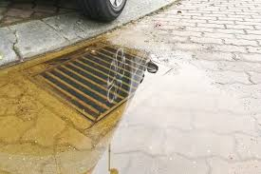

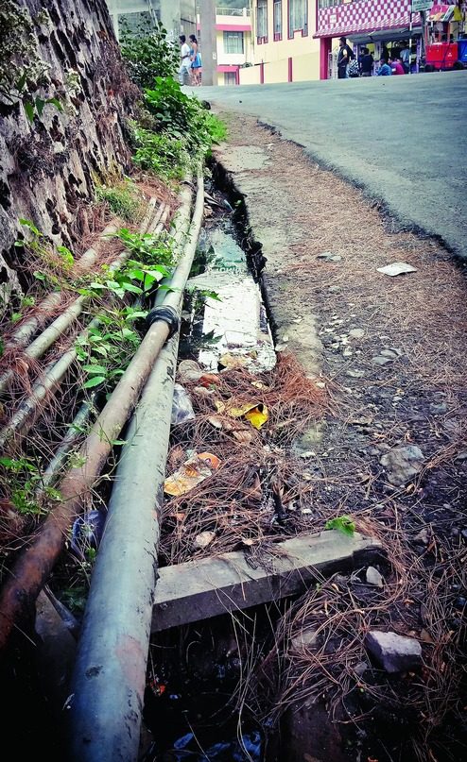

### Impact of Drainage Blockage in India

Drainage blockages in India have widespread and significant impacts, affecting various aspects of society, economy, and the environment. Here are the key impacts:

#### 1. **Urban Flooding**

* **Increased Flood Risk:** Blocked drainage systems exacerbate the risk of urban flooding, especially during the monsoon season when heavy rainfall is common.
* **Waterlogging:** Prolonged waterlogging in streets and residential areas disrupts daily life, making transportation difficult and sometimes dangerous.

#### 2. **Health Hazards**

* **Waterborne Diseases:** Stagnant water due to blocked drains becomes a breeding ground for mosquitoes and other pests, leading to the spread of diseases such as dengue, malaria, and cholera.
* **Sanitation Issues:** Overflowing drains can lead to contamination of drinking water sources, exacerbating public health crises.

#### 3. **Environmental Pollution**

* **Soil and Water Contamination:** Blockages often cause sewage overflows, contaminating soil and water bodies with harmful pollutants and pathogens.
* **Aquatic Ecosystems:** Polluted water from blockages can severely impact local aquatic ecosystems, harming fish and other wildlife.

#### 4. **Economic Costs**

* **Property Damage:** Flooding and waterlogging cause significant damage to homes, businesses, and infrastructure, leading to high repair and replacement costs.
* **Lost Productivity:** Disruptions caused by drainage blockages and subsequent flooding can lead to decreased productivity, affecting businesses and daily economic activities.
* **Healthcare Costs:** The increase in health issues due to poor sanitation and waterborne diseases leads to higher medical expenses for individuals and public health systems.

#### 5. **Social Impact**

* **Displacement:** Severe blockages and flooding can displace communities, particularly in low-lying and informal settlement areas, leading to temporary or permanent relocation.
* **Quality of Life:** Frequent blockages and associated problems reduce the overall quality of life, causing stress and inconvenience for residents.

#### 6. **Infrastructure Damage**

* **Road and Building Integrity:** Prolonged water exposure from blockages can weaken road surfaces, foundations, and building structures, leading to long-term infrastructure damage.
* **Maintenance Burden:** Blocked drainage systems require extensive maintenance efforts, placing a strain on municipal resources and budgets.

#### 7. **Agricultural Impact**

* **Crop Damage:** In rural and peri-urban areas, blocked drainage can lead to waterlogging in agricultural fields, damaging crops and reducing yield.
* **Soil Quality:** Repeated waterlogging affects soil quality and fertility, impacting long-term agricultural productivity.

#### 8. **Increased Vulnerability to Climate Change**

* **Resilience Issues:** Blocked drainage systems reduce the resilience of urban areas to cope with extreme weather events, which are becoming more frequent due to climate change.
* **Adaptation Challenges:** Addressing drainage issues is critical for urban areas to adapt to changing climate patterns and increased rainfall intensity.

**Images**

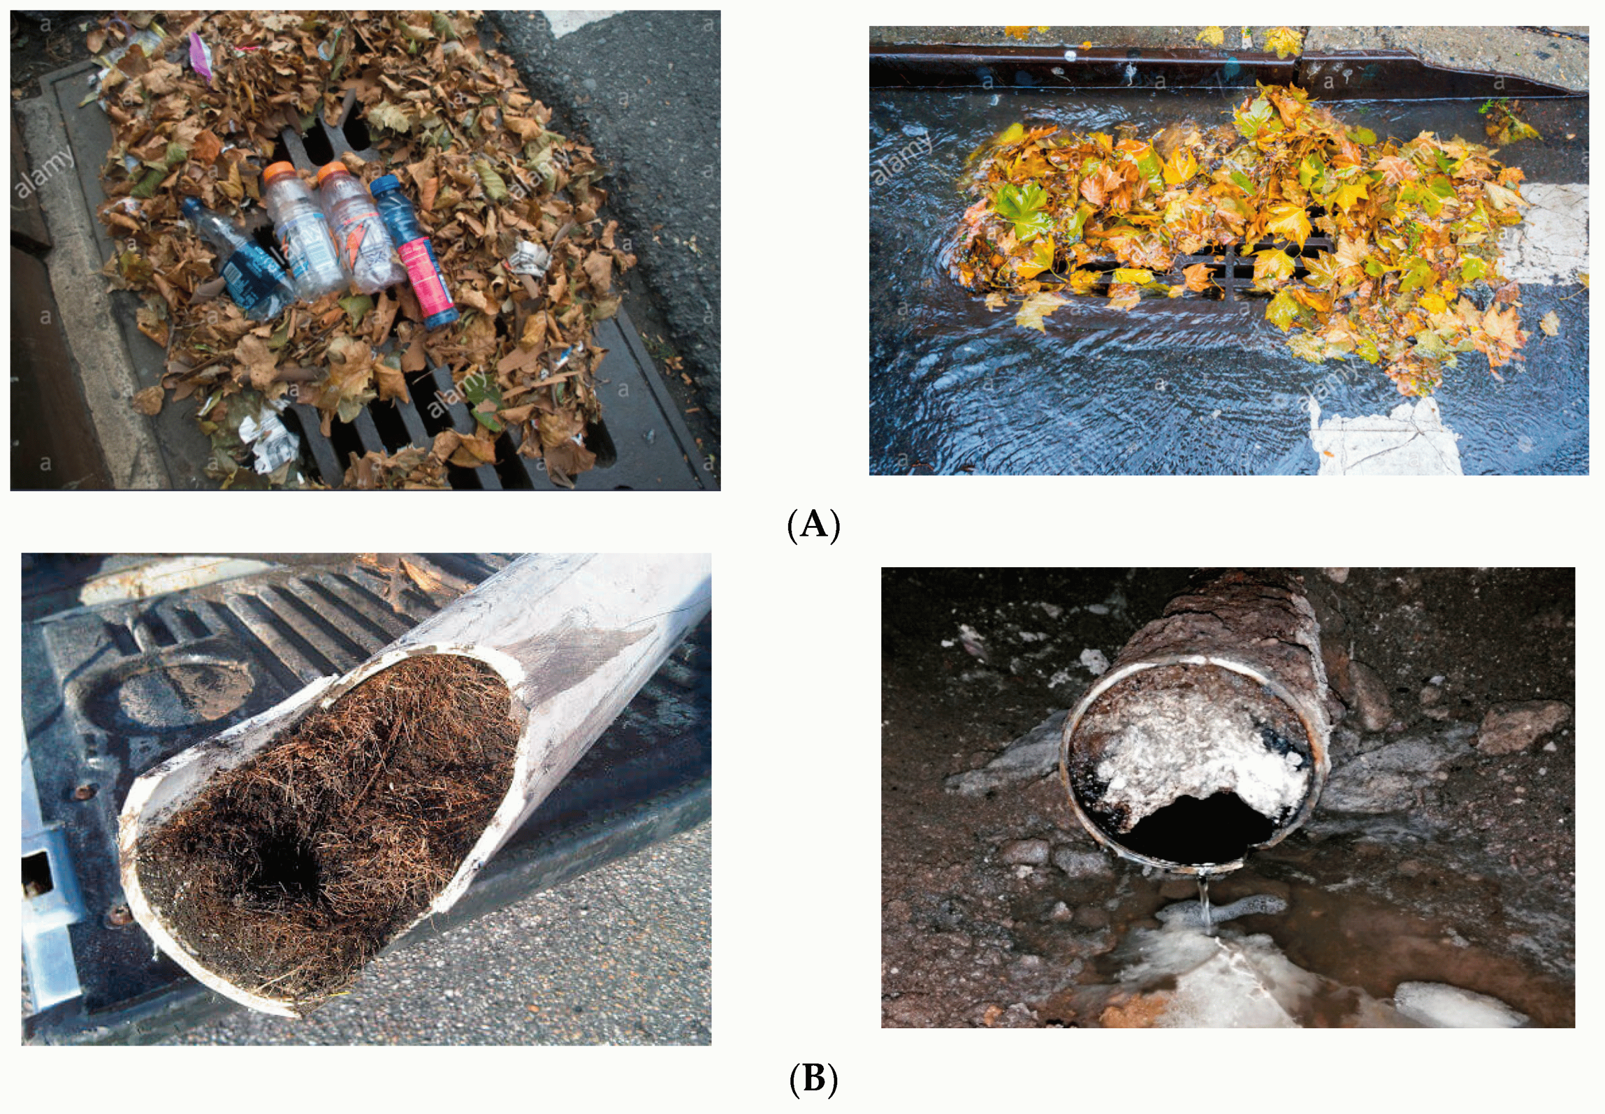

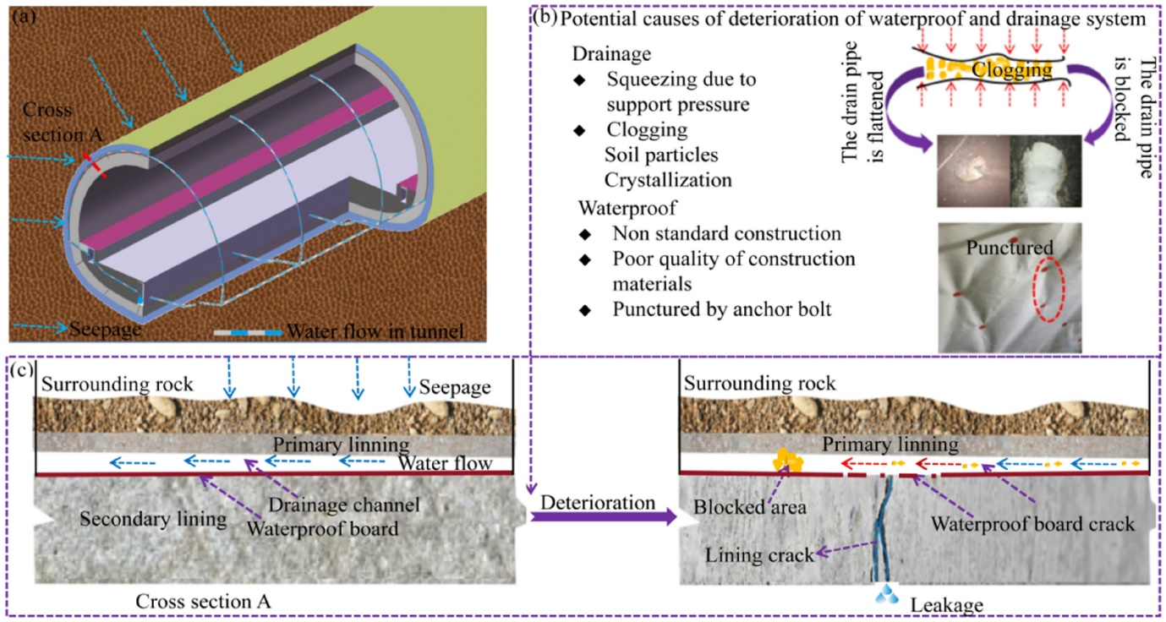

### Existing Solutions for Drainage Blockage Management

Managing drainage blockages requires a combination of preventive measures, advanced technologies, and efficient maintenance practices. Here are some of the existing solutions commonly used to manage and mitigate drainage blockages:

#### **1. Manual Inspection and Cleaning**

**a. Routine Inspections:**

* Regularly scheduled manual inspections are conducted to check for blockages, debris accumulation, and structural damage.
* Drainage workers often use simple tools like rods and hooks to manually remove debris and clear blockages.

**b. Desilting Operations:**

* Manual desilting involves removing sediment, sludge, and other materials that settle at the bottom of drainage systems, typically using shovels, buckets, and other hand tools.

#### **2. Mechanical Cleaning Methods**

**a. Jetting and Flushing:**

* High-pressure water jetting is used to clear blockages and clean the inside of pipes. The force of the water dislodges debris and build-up, flushing it out of the system.
* Flushing involves using large volumes of water to wash away sediments and debris from drainage pipes.

**b. Suction Machines:**

* Vacuum trucks equipped with powerful suction pumps are used to remove debris, sludge, and wastewater from blocked drains.
* These trucks can reach deep into drainage systems and are particularly effective for clearing large blockages.

#### 3. **Advanced Technologies**

**a. CCTV Inspection:**

* Closed-circuit television (CCTV) cameras are deployed inside drainage pipes to provide real-time visual inspection of the interior.
* CCTV inspections help identify the exact location and nature of blockages, structural damage, and other issues without the need for extensive excavation.

**b. Robotic Inspection and Cleaning:**

* Robotic systems equipped with cameras and sensors navigate through drainage pipes to inspect, detect blockages, and even perform minor cleaning tasks.
* Robots are particularly useful in accessing hard-to-reach areas and reducing the need for manual labour in hazardous conditions.

**c. Acoustic and Ultrasonic Sensors:**

* Acoustic sensors use sound waves to detect changes in the flow and identify potential blockages based on the sound profile of water movement.
* Ultrasonic sensors measure the level and flow rate of water, helping detect blockages and sediment build-up by analysing the reflections of ultrasonic waves.

#### 4. **Preventive Measures**

**a. Fat, Oil, and Grease (FOG) Management:**

* Installing grease traps and interceptors in commercial kitchens and food processing units to capture FOG before it enters the drainage system.
* Public education campaigns to raise awareness about the proper disposal of cooking fats and oils.

**b. Root Infiltration Prevention:**

* Using chemical root inhibitors or installing physical barriers to prevent tree roots from penetrating drainage pipes.
* Regularly trimming trees and vegetation near drainage systems to minimize root growth.

**c. Solid Waste Management:**

* Improving municipal waste collection services to reduce littering and illegal dumping of waste into drains.
* Encouraging recycling and proper waste segregation to minimize the amount of solid waste entering the drainage system.

#### 5. **Integrated Urban Water Management**

**a. Sustainable Drainage Systems (Suds):**

* Implementing Suds techniques, such as green roofs, permeable pavements, and rain gardens, to manage stormwater runoff and reduce the load on drainage systems.
* Suds helps in natural infiltration, storage, and gradual release of stormwater, minimizing the risk of blockages and flooding.

**b. Smart Drainage Systems:**

* Utilizing Internet of Things (IoT) sensors and smart monitoring systems to provide real-time data on the condition and performance of drainage systems.
* Automated alerts and predictive maintenance schedules based on data analytics help in proactive blockage management.

#### 6. **Policy and Regulatory Frameworks**

**a. Building Codes and Regulations:**

* Enforcing strict building codes and regulations to ensure proper design, construction, and maintenance of drainage systems in new developments.
* Implementing penalties for illegal connections, encroachments, and improper waste disposal practices that contribute to blockages.

**b. Public-Private Partnerships:**

* Collaborating with private sector companies to invest in and manage drainage infrastructure, leveraging their expertise and resources for better maintenance and innovation.

### Conclusion

Effective drainage blockage management requires a multi-faceted approach that combines traditional manual methods with advanced technologies and preventive measures. By leveraging a combination of manual and mechanical cleaning, advanced inspection technologies, preventive strategies, and smart infrastructure management, cities can significantly reduce the occurrence and impact of drainage blockages. Policymakers and urban planners must work together to implement these solutions comprehensively, ensuring sustainable and resilient urban drainage systems.

**TEAM MEMBERS**:

NITHISH KUMAR MP - BU21EECE0100518

B.V. KISHORE KUMAR - BU21EECE0100333

M.SRI SAI HARSHITH – BU21EECE0100407

**PROJECT GUIDE: -**

Dr Ramesha M